NO. | Name | Common name | Glycan Structure
1 | Ketodeoxynonulonsonic Acid | Man
2 | (Man)9(GlcNAc)2 Mannonanose-di-(N-acetyl-D-glucosamine) | Man-9 Glycan | 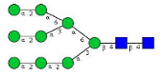
3 | (Man)3(GlcNAc)2  Mannotriose-di-(N-acetyl-D-glucosamine) | Man-3 Glycan | 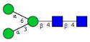
4 | α-D-Man-(1→6)-D-Man 6-O-α-D-Mannopyranosyl-D-mannopyranose | 6α-Mannobiose
5 | α-D-Man-[1→2]-D-Man 2-O-α-D-Mannopyranosyl-D-mannopyranose | 2α-Mannobiose | 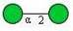
6 | α-Man-(1→3)(α-Man-[1→6])-α-Man-(1→6)(α-Man-[1→3])-Man | 3α,6α-Mannopentaose | 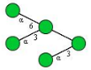
7 | N-Acetyl-Neuraminic | NeuAc
8 | α-NeuNAc-(2→3)-β-D-Gal-(1→3)-(α-L-Fuc-[1→4])-D-GlcNAc 3′-SLeª | 3′-Sialyl-Lewis-a tetrasaccharide | 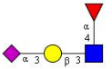
9 | 3′-N-Acetylneuraminyl-N-acetyllactosaminesodium | 3-(N-Acetyl-L-cystein-S-yl
10 | 3′-Sialyllactose | 3'-SL | 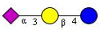
11 | 6′-Sialyllactose | 6'-SL | 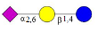
12 | A2 Glycan, N-Linked Oligosaccharide, Disialylated, Biantennary | NA2F | 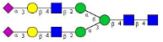
13 | Sialyllactose | SL
14 | Fucose | Fuc
15 | Lacto-N-difucohexaose I | LNDF I | 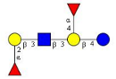
16 | Lacto-N-fucopentaose I | LNF-I | 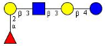
17 | α-Gal-(1→3)-(α-Fuc-[1→2])-β-Gal-(1→3)-(α-Fuc-[1→4])-GlcBLe^{b}-Pentasaccharide | B-Pentasaccharide | 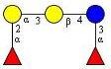
18 | α-Fuc(1→2)-β-Gal-(1→3)-(α-Fuc-[1→4])-GlcNAcLe^{b} glycan | Lewis-b tetrasaccharide | 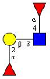
19 | α-Fuc-(1→2)-β-Gal-(1→4)-(α-Fuc-[1→3])-GlcNAc | Lewis-Y tetrasaccharide | 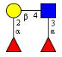
20 | α-L-Fuc-(1→2)-β-D-Gal-(1→4)-D-Glc | 2′-Fucosyl-D-lac | 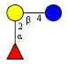
21 | α-Fuc-(1→2)-β-Gal-(1→4)-GlcNAc 2′-Fucosyl-N-acetyllactosamine Blood group H trisaccharide | H-Trisaccharide | 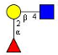
22 | α-L-Fuc-(1→3)-D-GlcNAc 2-Acetamido-2-deoxy-3-O-α-L-fucopyranosyl-D-glucopyranose | 3α-Fucosyl-N-acetylglucosamine | 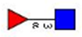
23 | Lacto-N-difucohexaoseII | LNDF II | 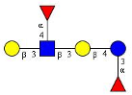
24 | α-Gal-(1→3)-(α-Fuc-[1→2])-β-Gal-(1→3)-(α-Fuc-[1→4])-GlcBLe^{b}-Pentasaccharide | iso-B-Pentasaccharide | 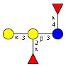
25 | α-GalNAc-(1→3)-(α-Fuc-[1→2])-β-Gal-(1→3)-(α-Fuc-[1→4])-Glc A-Le^{b}-Pentasaccharide | iso-A-Pentasaccharide | 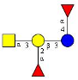
26 | Galactose | Gal
27 | Lactose | Lac | 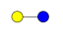
28 | Lacto-N-tetraose | LNT
29 | β-D-Gal-(1→4)-D-GlcNAc 2-Acetamido-2-deoxy-4-O-β-D-galactopyranosyl-D-glucopyranose LN N-Acetyl-4-O-(β-D-galactopyranosyl)-D-glucosamine | N-Acetyl-D-lactosamine
30 | 4β-Galactobiose | 4β-Gal | 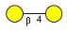
31 | Galacto-N-biose | GLNBP
32 | α-D-Gal-(1→3)-β-D-Gal-(1→4)-α-D-Gal-(1→3)-D-Gal 3-O-(4-O-[3-O-α-D-Galactopyranosyl-β-D-galactopyranosyl]-α-D-galactopyranosyl)-D-galactopyranose | 3α,4β,3α-Galactotetraose
33 | α-D-Gal-(1→4)-β-D-Gal-(1→4)-D-Glc 4-O-(4-O-α-D-Galactopyranosyl-β-D-galactopyranosyl)-D-glucopyranose | Globotriose | 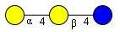
34 | N-acetylgalactosamine | GalNAc | 
35 | Ser-O-2-amino-2-deoxy-beta-D-glucopyranose hydrochloride | GlcNAc-O-Ser | 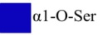
36 | Glucose | Glu
37 | α1,4'-beta-glycoside[4-O -(beta-D-Glucopyranosyl)-beta-D-glucopyranose] | Cellobiose
38 | 2-amino-2-deoxy-beta-D-glucopyranose hydrochloride | GlcNAc | 
39 | (GlcNAc)2Man3(GlcNAc)2 Asialo, agalacto, biantennary N-glycan Mannotriose-di-(N-acetylglucosamine), bis(N-acetylglucosaminyl) | NGA2 Glycan | 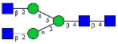
40 | Xylose | Xyl | 
41 | Hyaluronic acid | HA | /

